< Consumer Trends Research Lab., Attachement of Consumer Insight >
Travel Consumer Weekly Trends Report - August 1st week 2016

"Consumer Insight", a research specialized firm, carried out "Travel Market Short-term Forecast Survey" from August 24, 2015 to the present from a total of 15,000 people (Weekly 300 people; men and women across the country from 20 to 60 in age) to collect data for travel plan. More specific content can be found at "Consumer Trends Research Lab." Website: http://consumerinsight.co.kr/etravel When you click the "Display Data", you can see the relevant data in graph.
Competitiveness of overseas  Travel destinations | Not wanting to visit again China and Hong Kong,  But wishing to visit Europe & North America  - High visit experiences to Japan, Southeast Asia & China  - Places to visit again are Europe and North America  More than a half of people "Have visited" Japan - China - South East Asia, but the opinion for "Wanting to visit again for sure" did not exceed 1/4. On the other hand, the visit experience to Europe and North America was less than one-quarter, but the response of "Wanting to visit again for sure" was more than a half. Travel consumers’ heart is already out of Asia and heading toward Europe and North America.  Consumer Insight, a travel research specialist firm, asked 1,000 travel intenders (within three months) in last June about which overseas travel destination they have been at least once until now and their revisit intention in the future. As a result, the most traveled overseas destination was Japan (62%), followed by Southeast Asia (60%), China (52%), Hong Kong / Macau (31%), the United States / Canada (25%), west Europe / Northern Europe (24%) and Oceania (18%), in order [Table 1]. The experience rate to Japan, China and Southeast Asia is high as matter of course because they are geographically adjacent with less time and cost burden. However, when this is close to the saturation state with all the people who can afford have been there, it has a significant meaning. On the other hand, Western Europe / Northern Europe and North America are the 2nd most visited area next to the Asian region (24% & 25%, respectively), yet only one in four people has traveled this area. It shows which is going down and which is emerging in Korean outbound market.  And then, where would be the travel destination to visit again by all means? More than half of those who traveled Western Europe / Northern Europe (56%), Eastern Europe (51%), Southern Europe (50%) and the United States / Canada (50%) wanted to go there again for sure. Following in the next were Central and South America (38%) & Oceania (35%), in order, while Asian regions are all in the bottom ranks including Japan (24%), Middle East / Southwest Asia (24%), Southeast Asia (22%), China ( 18%) & Hong Kong / Macau (18%), in order, all of which did not reach a quarter. China, in particular, remained at the lowest ranks along with Hong Kong / Macau. This indicates that the travel experience to Chinese territory was a disappointment.  [Table 1] Overseas travel destination visit experience and re-visit intention  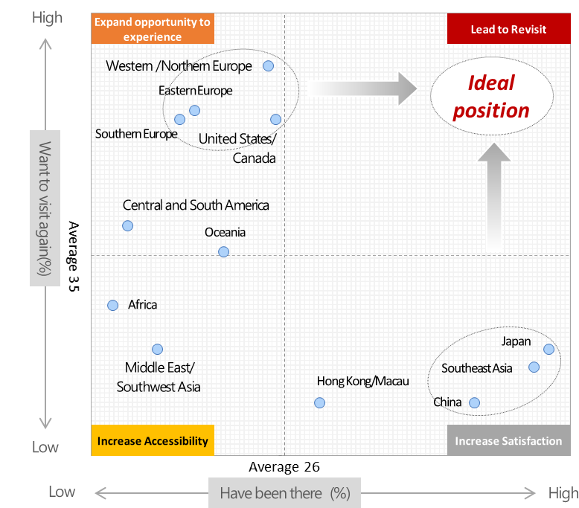  The most ideal status considered by all the tourist spots is a place with a lot visitors as well as a high revisit intention [Figure 1]. Asia regions with close experience rate to saturation should be travel destinations that travelers satisfy and expect another, whereas North America and Europe should provide opportunity to more people within a range of not impairing the current satisfaction.  [Figure 1] Overseas travel destination visit experience and re-visit intention  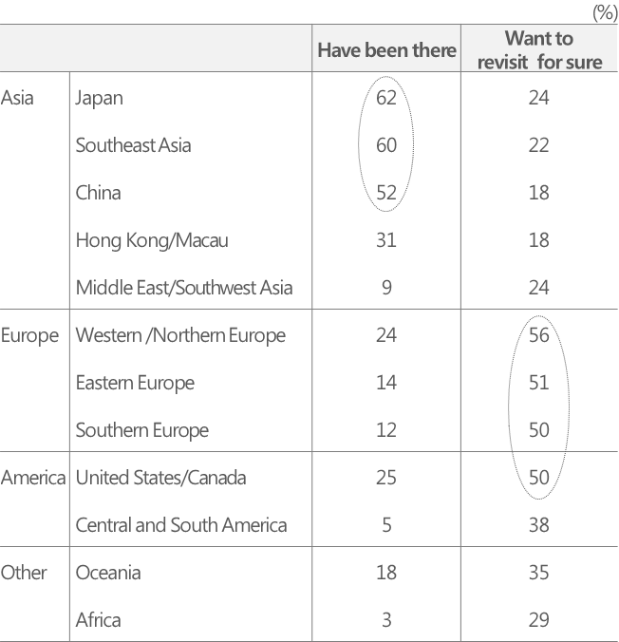  In the case of China, although it is located at the best position with the world's highest level of tourism resources (cultural heritage and the natural environment), the lowest re-visit intention of Korean consumers brings a lot to think about. Reflection on who and how the valuable industry resources in the short distance has damaged is necessary, while North America and Europe must learn a lesson from it.

- Inquiry –

Chief researcher/Ph.D, Kim, Min-Hwa kimmh@consumerinsight.kr
Senior researcher/Ph.D, Chung, Kyung-Sik jungks@consumerinsight.kr
Senior researcher/Ph.D, Moon, Ji-Hyo moonjh@consumerinsight.kr

